Project – 4
Form submission system by webhook
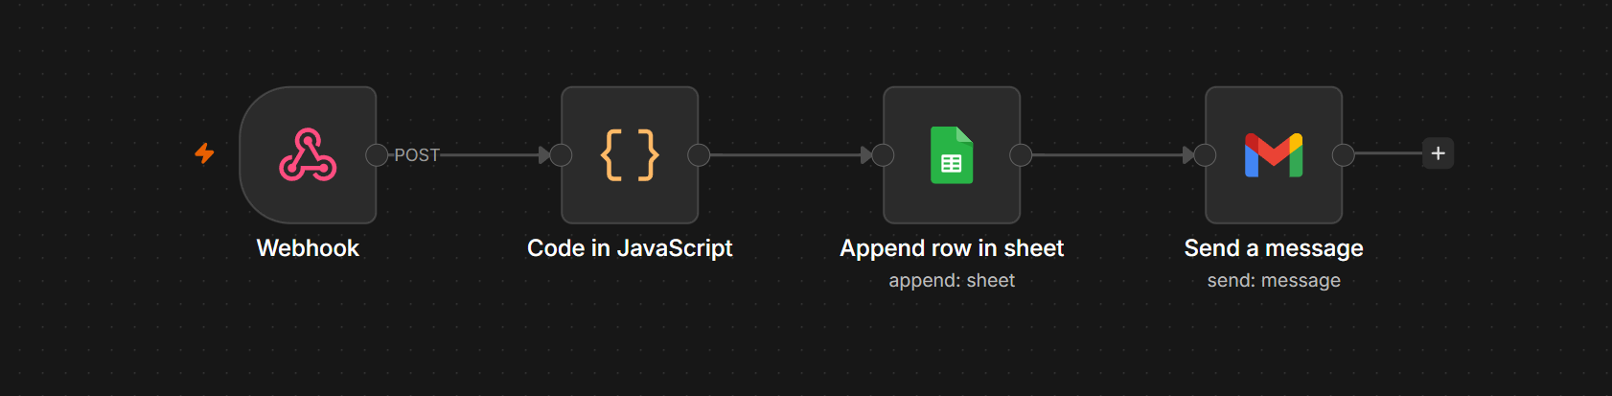
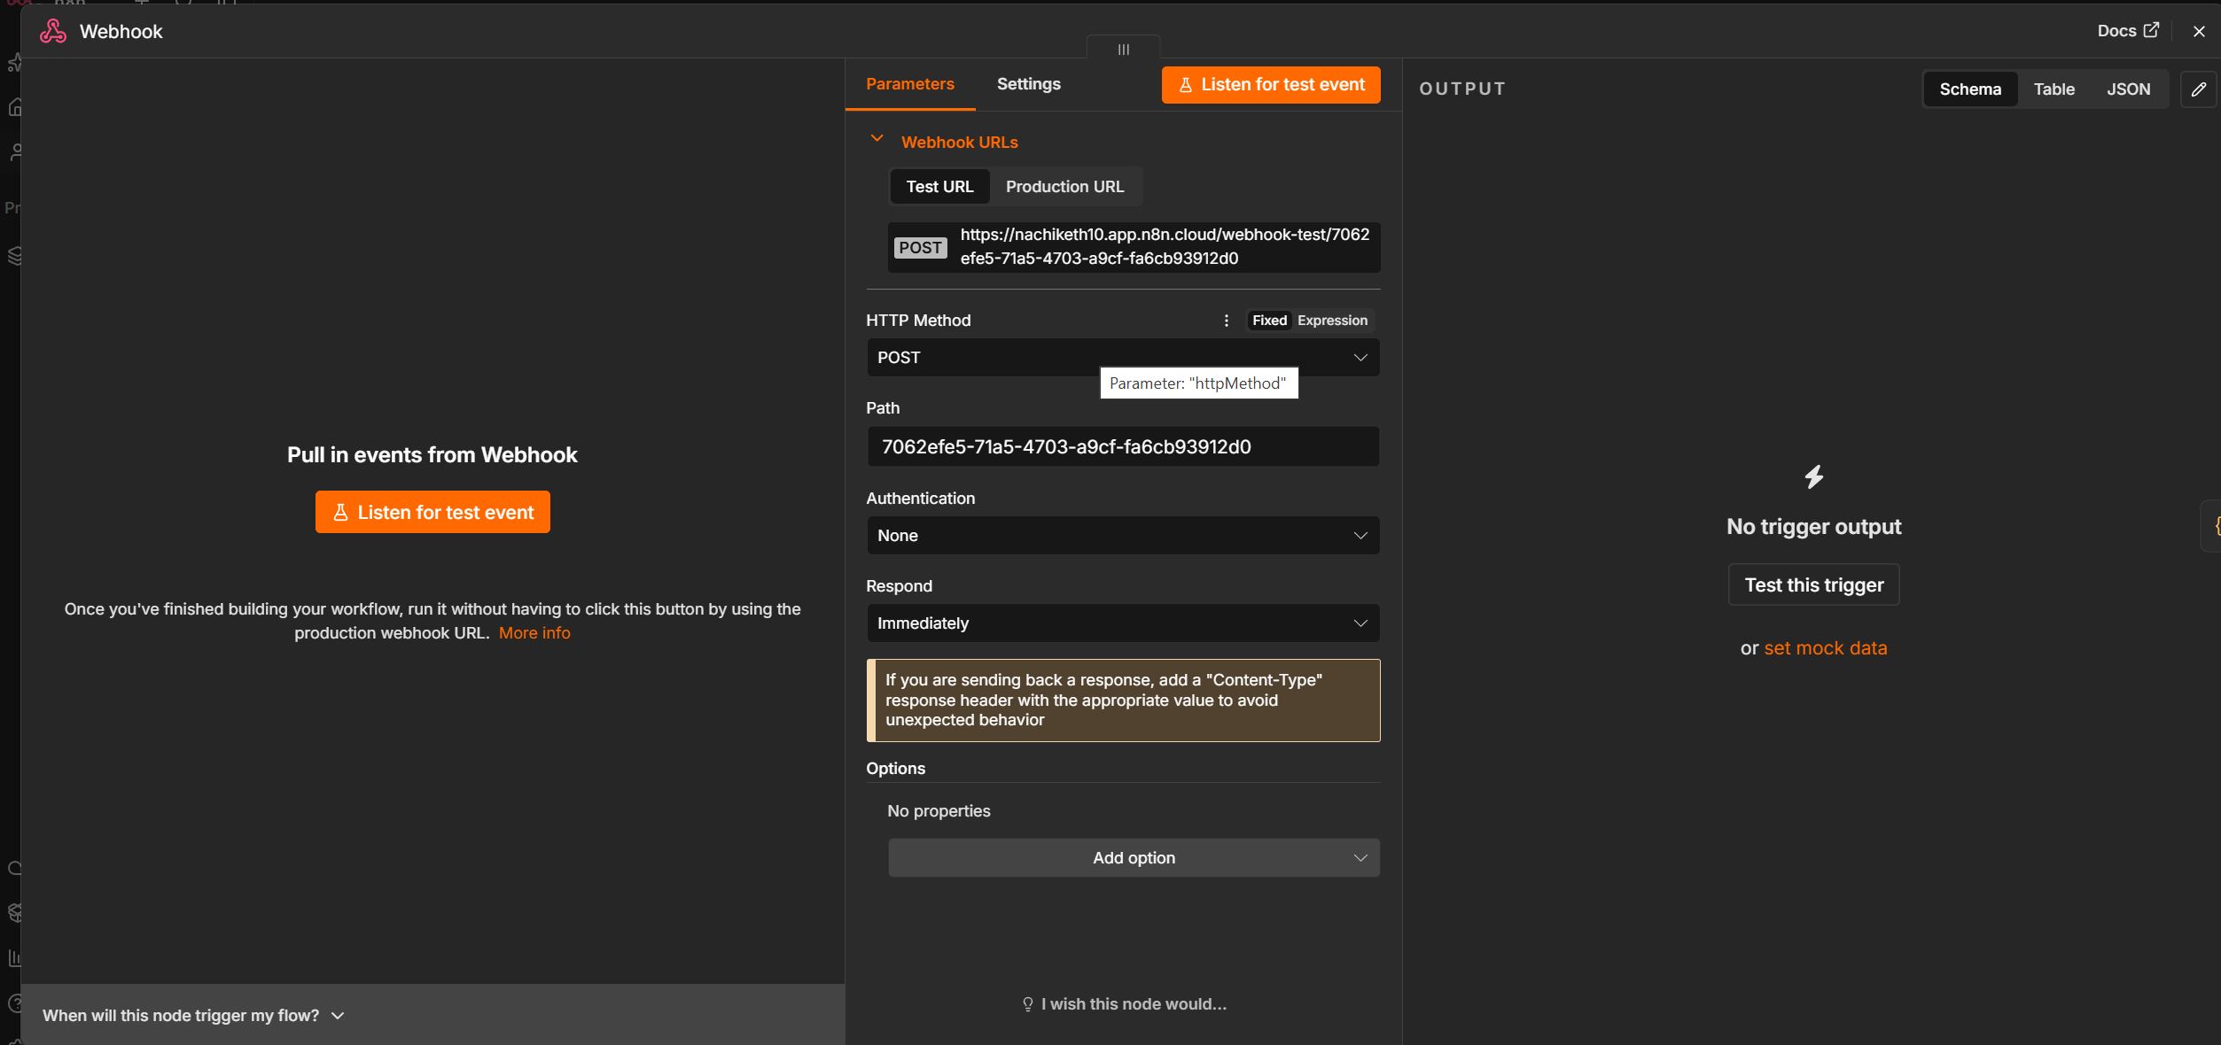
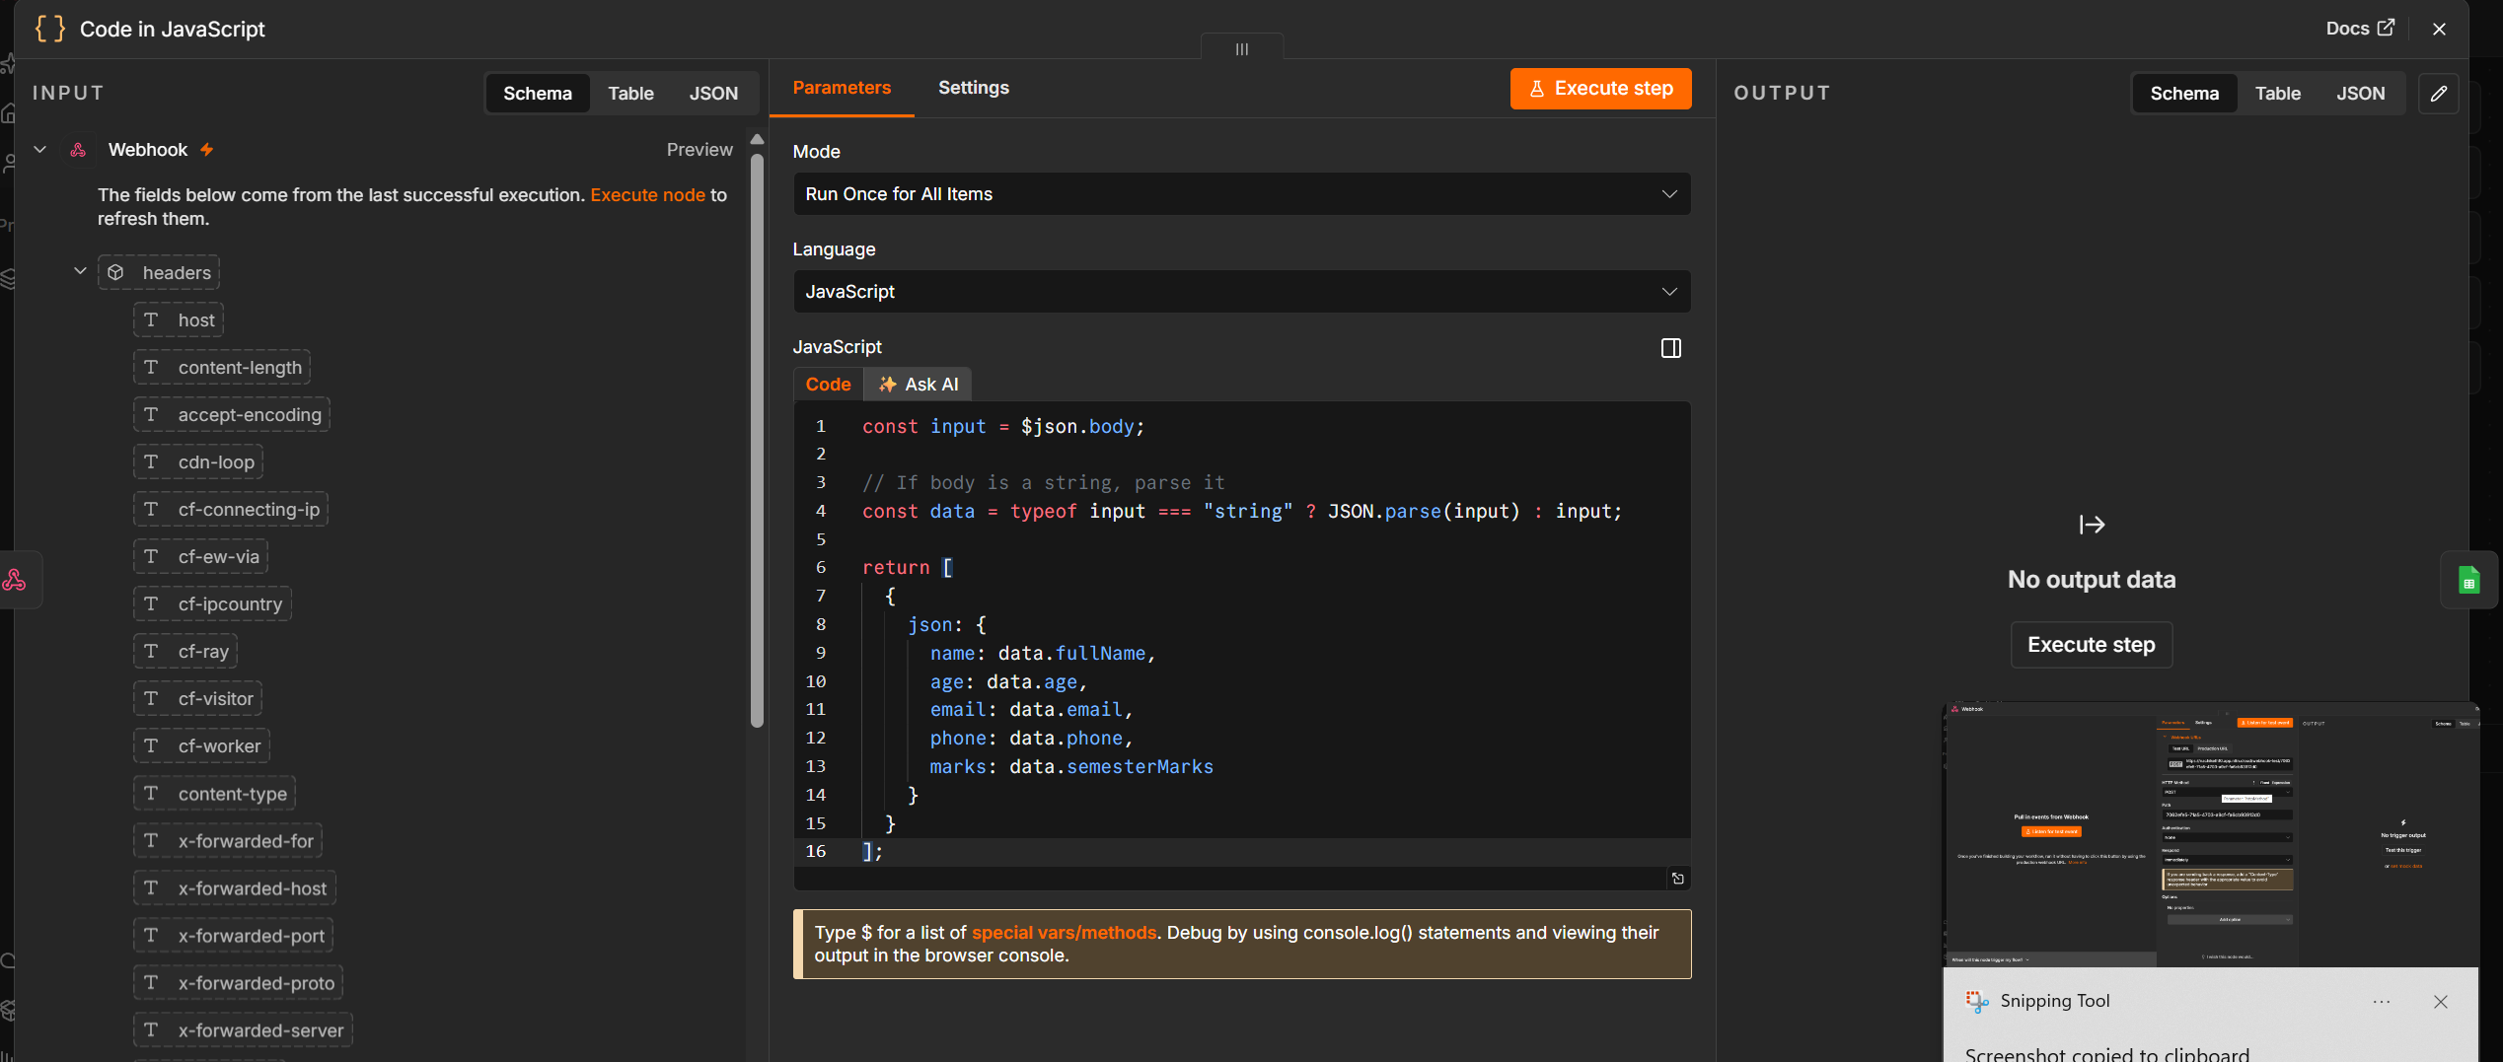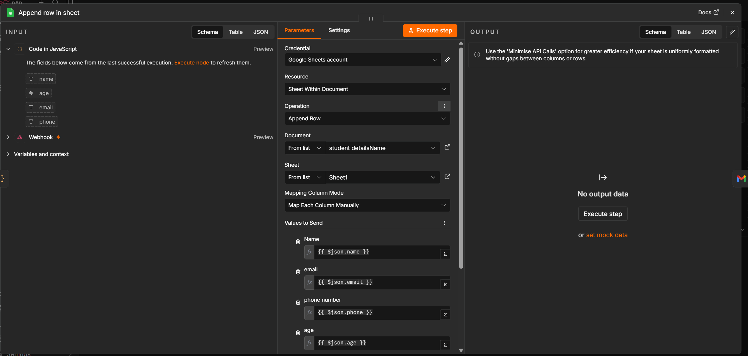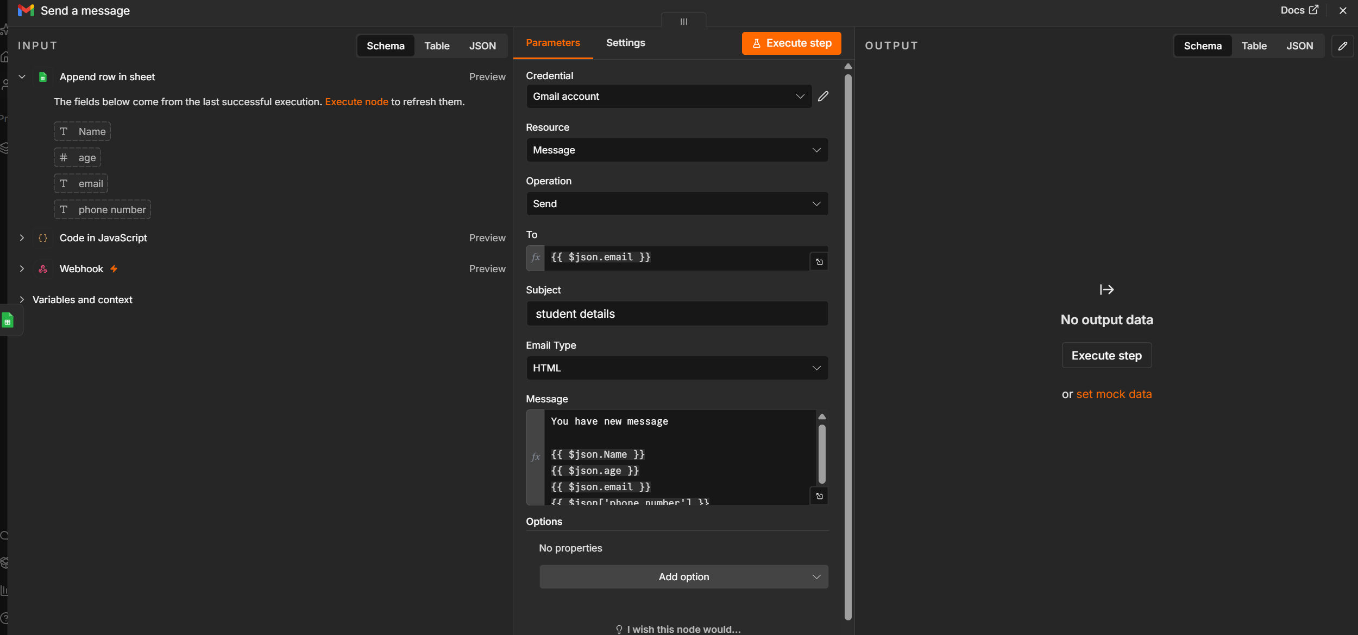
Step -1
Open chatgpt and paste this
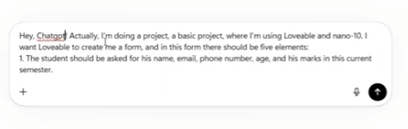
Paste test url to lovable and
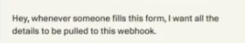
Code
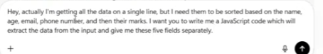

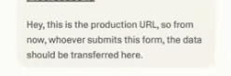
-------------------------------=------------------------------------------
Automation Workflow Documentation
Student Data Collection and Notification Automation using n8n

Document Information
Project Title: Student Data Collection Automation using n8n
Platform: n8n
Purpose: Automatically collect student information from a webhook request, process the received data, store it in Google Sheets, and send an email notification.

1. Overview
This automation is designed to receive student information through an HTTP Webhook, process the incoming JSON data using JavaScript, save the extracted information into a Google Sheet, and finally send a confirmation email using Gmail.
The workflow eliminates manual data entry and ensures that every student submission is automatically recorded and acknowledged.

2. Workflow Architecture
Student Form
│
▼
Webhook (POST Request)
│
▼
JavaScript Code Node
(Process JSON Data)
│
▼
Google Sheets
(Append New Row)
│
▼
Gmail
(Send Confirmation Email)

3. Workflow Description
Step 1: Webhook Node
Purpose
The Webhook node acts as the entry point of the automation. It listens for incoming HTTP POST requests containing student information.
Request Type
POST
Expected Input
{
"fullName": "John Doe",
"age": 21,
"email": "john@gmail.com",
"phone": "9876543210",
"semesterMarks": 89
}
Output
The received JSON data is forwarded to the JavaScript Code node.

Step 2: JavaScript Code Node
Purpose
The Code node processes the incoming webhook data and extracts the required student fields.
JavaScript Used
const input = $json.body;

// If body is a string, parse it
const data = typeof input === "string"
? JSON.parse(input)
: input;

return [
{
json: {
name: data.fullName,
age: data.age,
email: data.email,
phone: data.phone,
marks: data.semesterMarks
}
}
];
Processing
The node performs the following operations:
- Reads the webhook payload.
- Parses the JSON if required.
- Extracts:
  - Student Name
  - Age
  - Email Address
  - Phone Number
  - Semester Marks
- Returns a clean JSON object for downstream nodes.
Output
{
"name": "John Doe",
"age": 21,
"email": "john@gmail.com",
"phone": "9876543210",
"marks": 89
}

Step 3: Google Sheets Node
Purpose
The Google Sheets node appends the processed student information into a spreadsheet.
Operation
Append Row
Columns
Column | Value
Name | John Doe
Age | 21
Email | john@gmail.com
Phone | 9876543210
Marks | 89
Example Spreadsheet
Name | Age | Email | Phone | Marks
John Doe | 21 | john@gmail.com | 9876543210 | 89
Alice | 20 | alice@gmail.com | 9988776655 | 95
Benefits
- Automatic record keeping.
- No duplicate manual entry.
- Easily accessible database.
- Can be shared with faculty or administrators.

Step 4: Gmail Node
Purpose
After storing the student's details successfully, the workflow sends an email notification.
Email Recipient
The student's email address extracted from the webhook.
Sample Subject
Student Registration Successful
Sample Email
Hello John Doe,

Your details have been successfully submitted.

Student Details

Name : John Doe
Age : 21
Email : john@gmail.com
Phone : 9876543210
Semester Marks : 89

Thank you.

Regards,
Student Management System
Benefits
- Instant confirmation.
- Improves user experience.
- Confirms successful submission.

4. Complete Data Flow
User submits form
│
▼
Webhook receives POST request
│
▼
JavaScript extracts required fields
│
▼
Google Sheets stores student data
│
▼
Gmail sends confirmation email
│
▼
Workflow Ends

5. Input Data Structure
{
"fullName": "John Doe",
"age": 21,
"email": "john@gmail.com",
"phone": "9876543210",
"semesterMarks": 89
}

6. Output Data Structure
{
"name": "John Doe",
"age": 21,
"email": "john@gmail.com",
"phone": "9876543210",
"marks": 89
}

7. Technologies Used
Technology | Purpose
n8n | Workflow Automation Platform
Webhook | Receive HTTP Requests
JavaScript | Process Incoming Data
Google Sheets API | Store Student Records
Gmail API | Send Confirmation Emails
JSON | Data Exchange Format

8. Workflow Advantages
- Fully automated student data processing.
- Eliminates manual data entry.
- Ensures accurate data extraction.
- Stores records in a centralized Google Sheet.
- Sends immediate email confirmations.
- Scalable for handling multiple submissions.
- Easy to maintain and extend.

9. Future Enhancements
- Add input validation before processing.
- Prevent duplicate student records.
- Include timestamps for each submission.
- Generate a unique Student ID automatically.
- Send SMS notifications in addition to emails.
- Integrate with a database such as MySQL or PostgreSQL.
- Build a dashboard using Power BI or Google Looker Studio for analytics.

10. Conclusion
This n8n workflow provides an end-to-end automation solution for collecting and managing student information. It begins by receiving data through a Webhook, processes the data using JavaScript, stores it in Google Sheets, and sends an automated confirmation email via Gmail. The solution is efficient, scalable, and minimizes manual effort, making it suitable for educational institutions and student management applications.’

